TOEFL SKILL 6 : COORDINATE CONNECTORS

Coordinate connectors, sesuai namanya, diaplikasikan sebagai penghubung satu klausa dengan klausa lainnya. Tanpa penghubung tersebut, maka struktur kalimat akan berantakan, sebab ada dua subjek dan kata kerja di dalamnya. Ada beberapa jenis coordinate connectors yang diaplikasikan pada kalimat-kalimat bahasa Inggris. Yang paling sering digunakan dalam tes TOEFL biasa disebut dengan “FANBOYS”
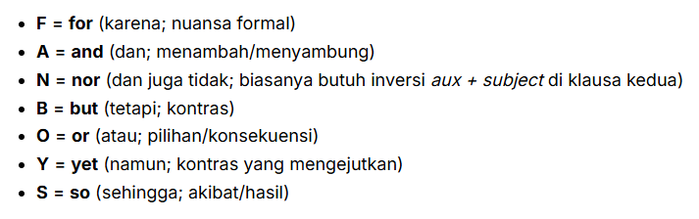
Rumus umum : S + V, FANBOYS S + V

Contoh :
- It was raining, so the game was canceled.
- She studied, and she passed.

Exercise
Choose correct or incorrect for the following question
- The rain clouds can be seen in the distance, but no has fallen
- Correct
- Incorrect

Choose A, B, C, or D for “incorrect structure” in the following sentences
- The researcher’s preliminary findings(A) and(B) the subsequent analysis has(C) a significant impact on the field(D).
- Findings
- And
- Has
- on the field
- The speaker was engaging(A), informative(B), and inspired(C) many people(D).
- Engaging
- Informative
- Inspired
- Many people

Choose A, B, C, or D for the following questions
- A bright light appeared in the sky, _______ a loud explosion was heard.
- Then
- And
- Later
- It
- The rain was heavy, so _______.
- The game was postponed
- Postponing the game
- Was postponed the game
- The game postponing

TOEFL SKILL 7 : USED ADVERB OF TIME AND CAUSE CONNECTORS

Adverb Connectors (Konektor Adverbial) adalah kata yang mengubah sebuah klausa penuh (S+V) menjadi anak kalimat (dependent clause). Karena statusnya “anak”, ia tidak bisa berdiri sendiri dan harus “menempel” pada induk kalimat (independent clause) untuk membentuk kalimat yang utuh.
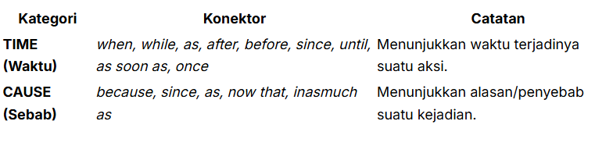
Contoh :
- He passed the exam because he studied hard.
- Because he studied hard, he passed the exam.
- The players left when the rain started
- When the rain started, the players left.

Pola Umum
- S + V Connector S + V
- Connector S + V , S + V

Exercise
Choose correct or incorrect for the following question
- Their backgrounds are thoroughly investigated before are admitted to the organization
- Correct
- Incorrect

Choose A, B, C, or D for “incorrect structure” in the following sentences
- Although(A) he was tired,(B) but(C) he kept working(D).
  - Although
  - Tired,
  - But
  - Working
- He was tired,(A) because(B) he(C) studied(D) all night.
- Tired,
- Because
- He
- Studied
- When(A) the show ended(B) the audience left(C) the theater quickly(D).
- When
- Ended
- Left
- Quickly

Choose A, B, C, or D for the following questions
- The student passed the exam ____ he studied very hard
- So
- And
- Because
- Then

TOEFL SKILL 8 : USED OTHER ADVERB CONNECTOR CORRECTLY

Skill 8 ini membahas dinamika yang lebih kompleks: syarat-syarat jadian (Kondisi), perbedaan karakter (Kontras), cara (Manner), dan tempat (Place).
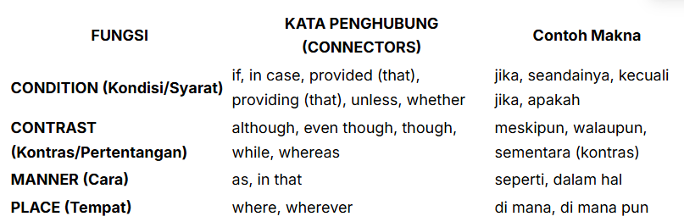
Contoh :
- He passed the exam although he did not study.
- Although he did not study, he passed the exam.
- You can enter if you have a ticket.
- If you have a ticket, you can enter.

Pola umum : sama dengan skill 7
Exercise
Choose correct or incorrect for the following question
- It is impossible to enter that program if you lack experience as a teacher
- Correct
- Incorrect

Choose A, B, C, or D for “incorrect structure” in the following sentences
- Even though(A) the traffic was heavy, but(B) they managed(C) to arrive(D) on time.
- Even though
- But
- they managed
- to arrive
- Unless(A) you don’t(B) submit the application by Friday(C), it will not be(D) considered.
- Unless
- you don’t
- by Friday
- it will not be
- Because(A) the sudden power outage,(B) all computers shut down(C) unexpectedly(D)
- Because
- power outage,
- shut down
- unexpectedly

Choose A, B, C, or D for the following questions
- the presentation ended, the audience asked numerous questions.
- The
- After
- So
- During

